Fake Job Detection System

Abstract:
The project titled “Fake Job Detection” is developed to identify and filter out fraudulent job postings using machine learning algorithms and data analysis techniques. The system helps users search for legitimate career opportunities by automatically analyzing job descriptions and details to predict their authenticity. The application is developed using the Python Django framework and features three primary modules: Customer (job seeker), Job Provider, and Admin. Customers can register, complete OTP verification, browse jobs, perform job analysis to detect fake listings, and manage their applications. Job Providers can securely post and manage job listings, while the Admin manages all user approvals and system activities. The proposed system reduces the risk of online employment scams, improves trust in digital recruitment, and provides an efficient, secure, and automated platform for safe job searching.

Introduction:
In today’s digital world, online job portals have become the primary method for recruitment. However, this shift has led to a significant increase in employment scams, where fraudulent job providers post fake opportunities to exploit job seekers. Students and professionals often find it difficult to distinguish between legitimate and fraudulent postings, leading to potential financial loss or data theft. The Fake Job Detection project is developed to solve this problem by applying analytical models to classify the legitimacy of job postings. The system allows job providers to upload job details, while customers can view these jobs and utilize the "Job Analysis" feature to verify their authenticity. Using the Django framework, the project provides secure authentication, efficient backend data handling, and user-friendly functionality to create a trustworthy recruitment environment.

Existing System
In the existing system:
- Job postings are reviewed and trusted manually by the applicant.
- Identifying fraudulent patterns in job descriptions is difficult.
- Job seekers can easily fall victim to phishing or advance-fee scams.
- No automated analysis or machine learning verification is available.
- Lack of an integrated platform that screens job providers before they post.
- Managing reporting and tracking of fake jobs is complex.
Drawbacks
- High chances of users falling for employment fraud.
- Time-consuming manual verification of company credibility.
- Poor organizational trust in online recruitment platforms.
- No secure centralized filtering system for fake jobs.
Proposed System
The proposed system is a Django-based web application integrated with a predictive model for Fake Job Detection. The system provides a centralized platform that bridges the gap between verified job providers and job seekers. The system provides:
- Secure User & Job Provider Registration with OTP Verification.
- Admin approvals for Job Providers to ensure initial vetting.
- Automated Job Analysis to evaluate the legitimacy of a listing.
- Application management for users to track their applied jobs.
- Notification System for updates.
- Secure Admin Control over the entire ecosystem.
Advantages
- Automatic detection of fraudulent job patterns.
- Protects job seekers from scams and data theft.
- Secure and verified environment for legitimate employers.
- Easy application and candidate management process.
- User-friendly interface with automated notifications.

Modules
Customer Module
This module handles all job seeker operations in the system.
Functions
- Home
- Login
- Registration
- View Notifications
- View Jobs
- View Job Details
- Job Analysis
- My Applications
- Change Password
- My Profile
- Edit Profile
- Forgot password
- OTP Verification.

Admin Modules
This module manages all administrative operations and controls the system.
Functions
- Home
- View Customer (Accept, Reject)
- View Job Provider (Accept, Reject)
- Add Notifications
- View Notifications
- View Contact
- Change Password
- Logout.

Job Provider Modules
This module manages all administrative operations and controls the system.
Functions
- Home
- Login
- OTP Verification
- Registration
- Add Job
- View Jobs
- View Job Details
- Edit Job Details
- View Applicants
- View Notification
- Change Password
- Forgot Password
- Logout

Scope and Objective of the Project
The scope of the project is to provide an automated fraud detection system for online recruitment using analytical models.
The application can be used by
- job seekers
- independent recruiters
- large organizations to ensure a safe hiring ecosystem.
OBJECTIVES OF THE PROJECT
- To identify fake jobs using data analysis.
- To provide a secure platform for legitimate job providers.
- To improve the overall security of online job applications.
- To provide a user-friendly job tracking and management system.
Software Requirements
- Operating System : Windows
- User Interface : HTML, CSS , JS and Bootstrap
- Programming Language : Python
- Web Applications : Django
- IDE/Workbench : Pycharm
- Database : MYSQL, SQL, SQLYOG
- Server Deployment : Apache Tomcat

Hardware Requirements

- Processor : Intel I3 Processor
- RAM : 4 GB
- Monitor : 15 inch color monitor or LED
- Hard disk : 256 GB
- Key board : Standard 102 keys
- Mouse : Optical

Functional Requirements

Functional requirements describe the behaviour and functionality of the system under specific conditions.
Main Pages
- Home
- About
- Contact
- Customer
- Admin
- Job provider

Customer Functions
- Home
- Login
- Registration
- View Notifications
- View Jobs
- View Job Details
- Job Analysis
- My Applications
- Change Password
- My Profile
- Edit Profile
- Change Password
- Forgot password
- OTP Verification
- Logout

Admin Functions
- Home
- View Customer(Accept, Reject)
- View Job Provider(Accept, Reject)
- Add Notifications
- View Notifications
- View Contact
- Change Password
- Logout

Job Provider Functions
- Home
- Login
- OTP Verification
- Registration
- Add Job
- View Jobs
- View Job Details
- Edit Job Details
- View Applicants
- View Notification
- Change Password
- Forgot Password
- Logout

Non-Functional Requirements

Non-functional testing is a type of software testing that verifies non-functional aspects of the product, such as performance, stability, and usability. Whereas functional testing verifies whether or not the product does what it is supposed to, non-functional testing verifies how well the product performs.
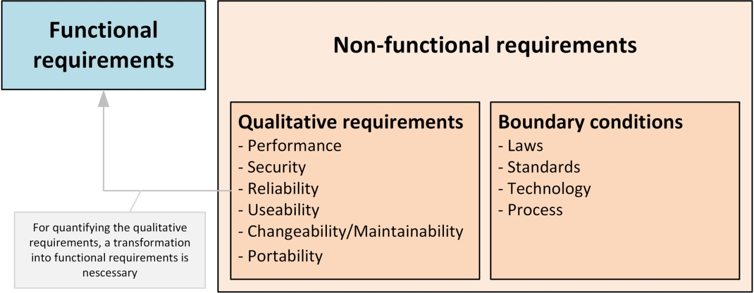

The system should shows below non-functional requirements
- High Security
- Mobile Responsiveness
- Fast Performance
- User-Friendly Interface
- Multi-browser Compatibility
- Easy Maintenance
- Scalability
- Reliable Data Storage
- Good Accessibility
- Efficient System Performance

Feasibility Study
The possibility of the undertaking is broke down during this stage and strategic plan is advanced with an exceptionally broad arrangement for the task and a few quotes. During project examination the likelihood investigation of the proposed project is to be completed. This is often to ensure that the proposed project isn't a weight to the organization. For practicality examination, some comprehension of the many necessities for the project is prime.
After the approval of the request to the organization and project guide, with an investigation being considered, the project request must be examined to determine precisely what the system requires.
Not all request projects are desirable or feasible. Some organization receives so many project requests from client users that only few of them are pursued. However, those projects that are both feasible and desirable should be put into schedule. After a project request is approved, it cost, priority, completion time and personnel requirement is estimated and used to determine where to add it to any project list. Truly speaking, the approval of those above factors, development works can be launched
An important outcome of preliminary investigation is the determination that the system request is feasible. This is possible only if it is feasible within limited resource and time. The different feasibilities that have to be analyzed are.

Economic Feasibility
This examination is completed to see the financial effect that the framework will wear the association. The measure of store that the organization can fill the innovative work of the framework is constrained. The consumptions must be advocated. Accordingly, the created framework also inside the budget and this was accomplished in light of the very fact that an outsized portion of the advancements utilized are uninhibitedly accessible. Just the modified items must be bought. Economic Feasibility or Cost-benefit is an assessment of the economic justification for a computer based project. As hardware was installed from the beginning & for lots of purposes thus the cost on project of hardware is low. And also in this project work all software is free and open source. It can be developed using our personal machines. So its economically its feasible to complete the project.

Technical Feasibility
According to Roger S. Pressman, Technical Feasibility is the assessment of the technical resources of the organization. The system is developed for platform Independent environment. The technical feasibility has been carried out. The system is technically feasible for development and can be developed with the existing facility.
This investigation is completed to see the technical practicality, that is, the specialized prerequisites of the framework. Any framework created must not have a popularity on the accessible specialized assets. This may prompt high requests on the accessible specialized assets. This may prompt high requests being assail the customer. The created framework must have a humble prerequisite, as just insignificant or invalid changes are required for actualizing this framework.
Social Feasibility
The part of study is to see the degree of acknowledgment of the framework by the client. This incorporates the way toward preparing the client to utilize the framework effectively. The client must not feel undermined by the framework, rather should acknowledge it as a requirement. The degree of acknowledgment by the clients exclusively relies upon the techniques that are utilized to show the client about the framework and to form him familiar with it. His degree of certainty must be raised with the goal that he's likewise able to make some helpful analysis, which is invited, as he's the last client of the framework.
Operational Feasibility
This region of attainability ensures that the undertaking fulfills all the prerequisites that were talks about during introductory necessity examination stage. This undertaking met all the necessities proposed before. It ensured that the modules examined during the proposing of the framework were actualized with stable precision and with no mistakes.
Operational Feasibility deals with the study of prospects of the system to be developed. This system operationally eliminates all the tensions of the Admin and helps him in effectively tracking the project progress. This kind of automation will surely reduce the time and energy, which previously consumed in manual work. Based on the study, the system is proved to be operationally feasible.

Process Models
1. Waterfall Model
Waterfall model indicates that all the SDLC steps will be going on step by step. In this model once one stage completed then only it will start the process. This will be implemented when the requirements well known and clearly defined.
In this model we can implement all the steps one by one. First we will do requirements gathering i.e in this step business analyst will collect the all functional requirements from the client and will discuss with the manager and development team. Second step is analysis where people can analyses the requirements so that they will do risk basement, risk mitigation, risk controlling steps. And also they will do the cost-time analysis to estimate the cost. They will also do the detail feasible study over the requirements of project.
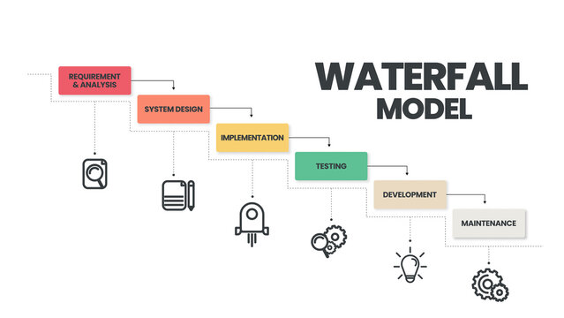
In third phase called design page generally people will design the project i.e architect will prepare the UML diagrams and prototypes for project. And then developers will start programming or coding based on design . Finally testing team will test the content to identify and fix the bugs. After successful user acceptance testing application will be deployed and maintained in the client machine.
The waterfall model was selected as the SDLC model due to the following reasons:
- When the requirements are very clear and not changed.
- Available technology is enough to implement.
- Project is easy and simple to understand to finish.
- And if we don’t have any confusion in requirements.
- We can easily manage the review process and task management.
- Every stage defined clearly and with timelines

2. Agile Scrum Model
Agile scrum methodology is the combination of the agile philosophy and the scrum framework. Agile means “incremental, allowing teams to develop projects in small increments. Scrum is one of the many types of agile methodology, known for breaking projects down into sizable chunks called “sprints.” Agile scrum methodology is good for businesses that need to finish specific projects quickly.
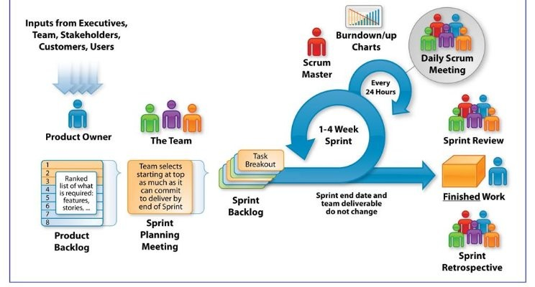
Agile scrum methodology is a project management system that relies on incremental development. Each iteration consists of two- to four-week sprints, where the goal of each sprint is to build the most important features first and come out with a potentially deliverable product. More features are built into the product in subsequent sprints and are adjusted based on stakeholder and customer feedback between sprints. Whereas other project management methods emphasize building an entire product in one operation from start to finish, agile scrum methodology focuses on delivering several iterations of a product to provide stakeholders with the highest business value in the least amount of time.
Agile scrum methodology has several benefits. First, it encourages products to be built faster, since each set of goals must be completed within each sprint’s time frame. It also requires frequent planning and goal setting, which helps the scrum team focus on the current sprint’s objectives and increase productivity.
The greatest benefit of agile scrum methodology is its flexibility. With the sprint-based model, the scrum team typically receives feedback from stakeholders after each sprint. If there are any problems or changes, the scrum team can easily and quickly adjust product goals during future sprints to provide more valuable iterations. This way, stakeholders are happier because they get exactly what they want after being involved every step of the way.

Client Server Architecture
Client server architecture, architecture of a computer network in which many clients (remote processors) request and receive service from a centralized server (host computer). Client computers provide an interface to allow a computer user to request services of the server and to display the results the server returns.
The Client-server model is a distributed application structure that partitions tasks or workloads between the providers of a resource or service, called servers, and service requesters called clients. In the client-server architecture, when the client computer sends a request for data to the server through the internet, the server accepts the requested process and delivers the data packets requested back to the client. Clients do not share any of their resources. Examples of the Client-Server Model are Email, World Wide Web, etc.
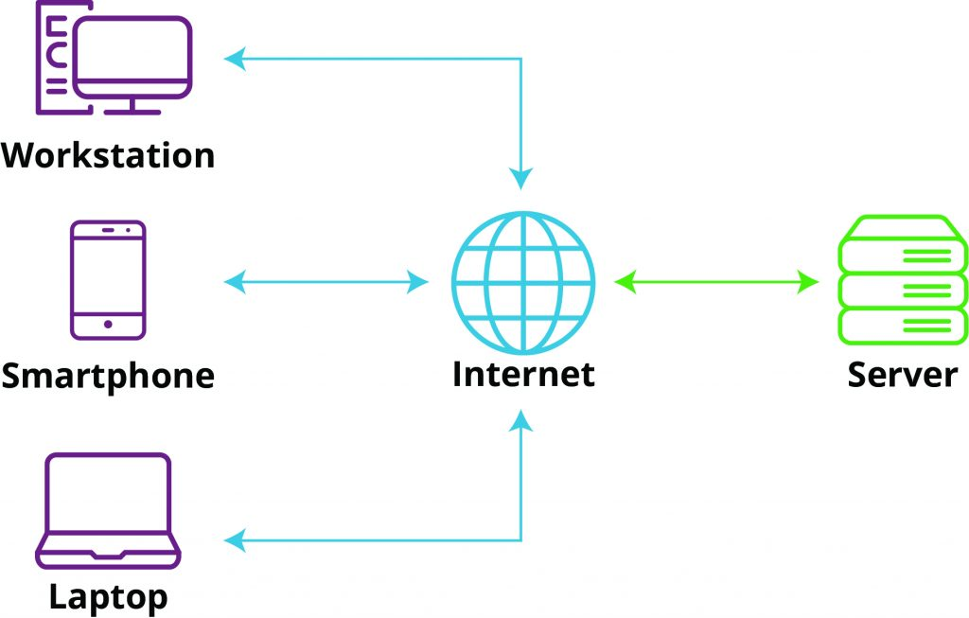

Web Application MVC Architecture
The Model-View-Controller (MVC) is a well-known design pattern in the web development field. It is way to organize our code. It specifies that a program or application shall consist of data model, presentation information and control information. The MVC pattern needs all these components to be separated as different objects.
The MVC pattern architecture consists of three layers:
- Model: It represents the business layer of application. It is an object to carry the data that can also contain the logic to update controller if data is changed.
- View: It represents the presentation layer of application. It is used to visualize the data that the model contains.
- Controller: It works on both the model and view. It is used to manage the flow of application, i.e. data flow in the model object and to update the view whenever data is changed.

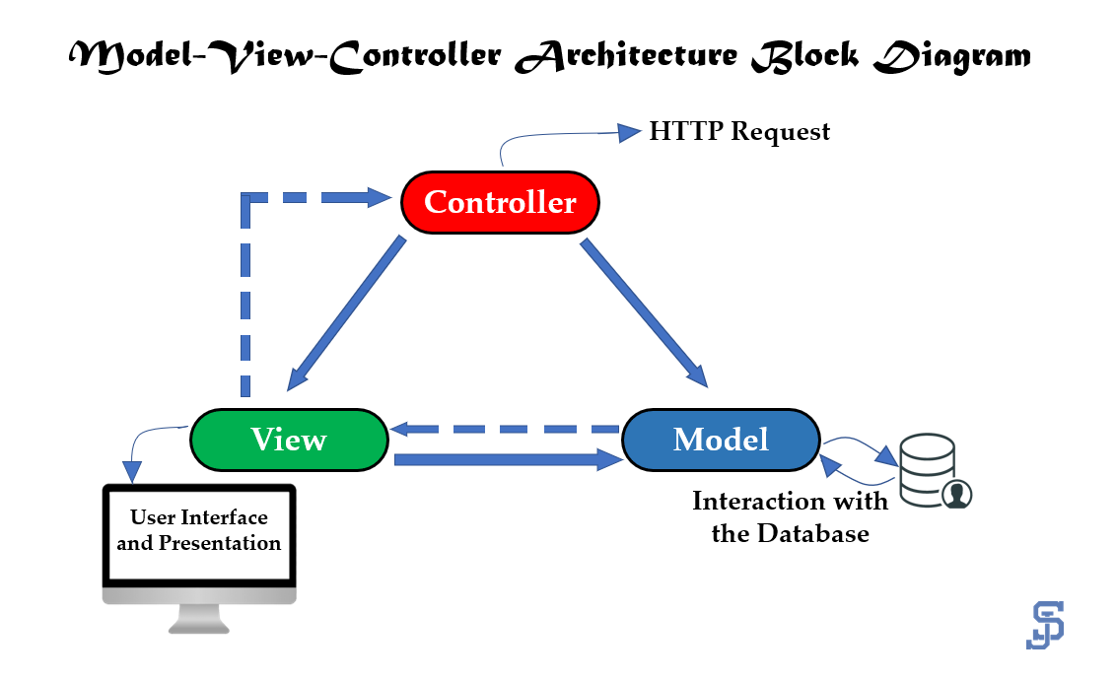

Web Application MVT Architecture
The MVT (Model View Template) is a software design pattern. It is a collection of three important components Model View and Template. The Model helps to handle database. It is a data access layer which handles the data.
The Template is a presentation layer which handles User Interface part completely. The View is used to execute the business logic and interact with a model to carry data and renders a template.
The model is going to act as the interface of your data. It is responsible for maintaining data. It is the logical data structure behind the entire application and is represented by a database (generally relational databases such as MySql, Postgres).
The View is the user interface — what you see in your browser when you render a website. It is represented by HTML/CSS/Javascript and Jinja files.

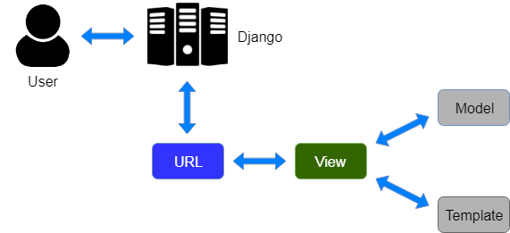

Conclusion:
The Fake Job Detection project is successfully designed and developed to create a safer environment for online recruitment. By successfully integrating analytical job evaluation into a robust Django backend, the system automates the process of identifying potentially fraudulent job details. The web application effectively separates responsibilities across the Customer, Job Provider, and Admin modules, ensuring tailored experiences, secure authentication, and precise data management. Ultimately, this project minimizes the manual effort required to vet companies, protects job seekers from employment scams, and establishes a highly reliable platform for transparent digital hiring.

